Start with the question and get the requirements
Design a Food delivery app (Tomato)
Functional requirements
- User can search for restaurant based on location
- User can add items to Cart
- User can check out by making payment
- User should get notified once order is placed successful
Non-functional requirements
- Each part of design should be scalable and modifiable
Discussing the happy flow
User come to app, select restaurant -> gets menu -> place order (2 types delivery and pick-up) -> payment (it will be a third party app we just need to integrate it) -> notification back to user
Menu
Restaurant
Payment
Pick-up
Delivery
order

cart

Notification

We have to discuss the User point of view not the delivery agent point of view
In LLD question 2 types of approach are there – top-down and bottom-up
Mostly we use bottom-up
Start with UML diagram

First we have restaurant and menuItem. They have strong composition relationship as we are assuming a menuItem can’t exist without the restaurant
There will be one more class to manage the restaurants or perform CRUD operation on them
There will be a weak relationship between Restaurant and RestaurantManager. So it is Aggregation
Restaurant manager will be a Singleton class because I don’t want multiple manager and everybody hold list of restaurants
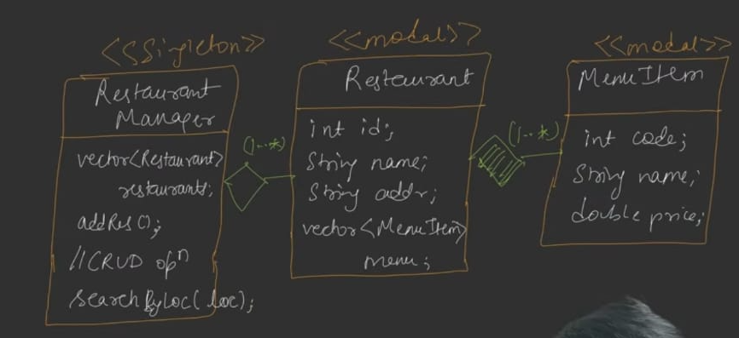
Let’s create User class which will have Cart, Now we have cart class which cant independently exist so strong composition relationship
The cart will have a simple association with restaurant and MenuItems
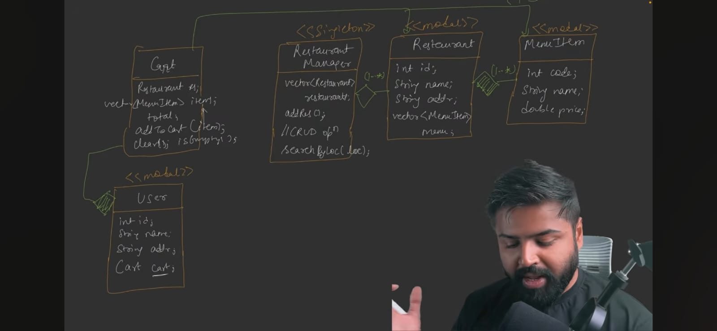
Let’s use Strategy design pattern for payment
Now who will call the payment strategy so create the order abstract class which will take the object of PaymentStretegy ps and it also have a getType() metod which will decide the type of order pick-up or delivery
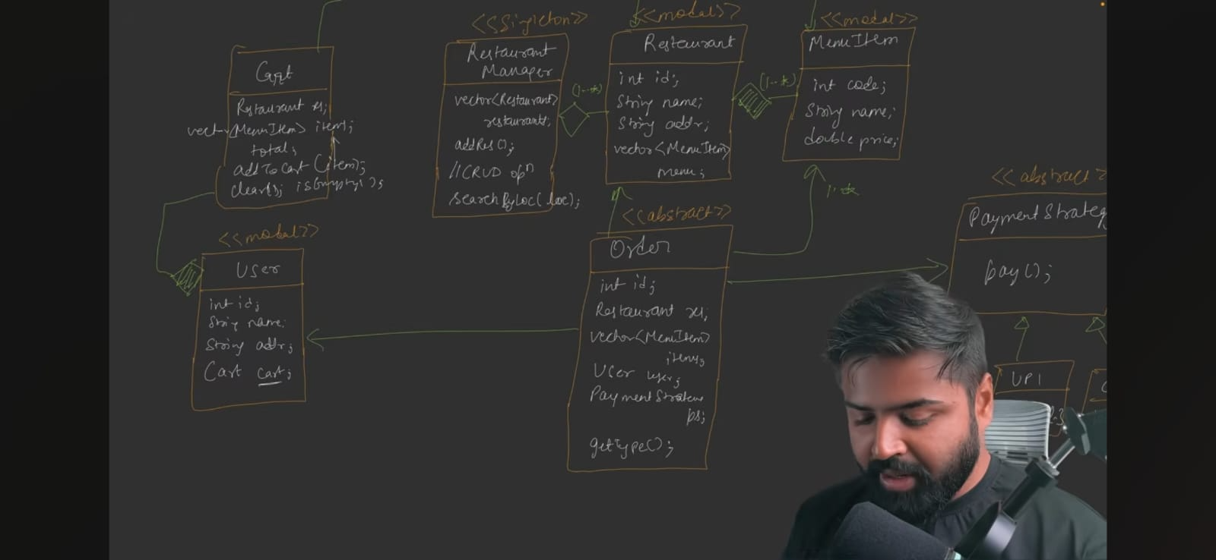
Let’s create the class for both the types of order
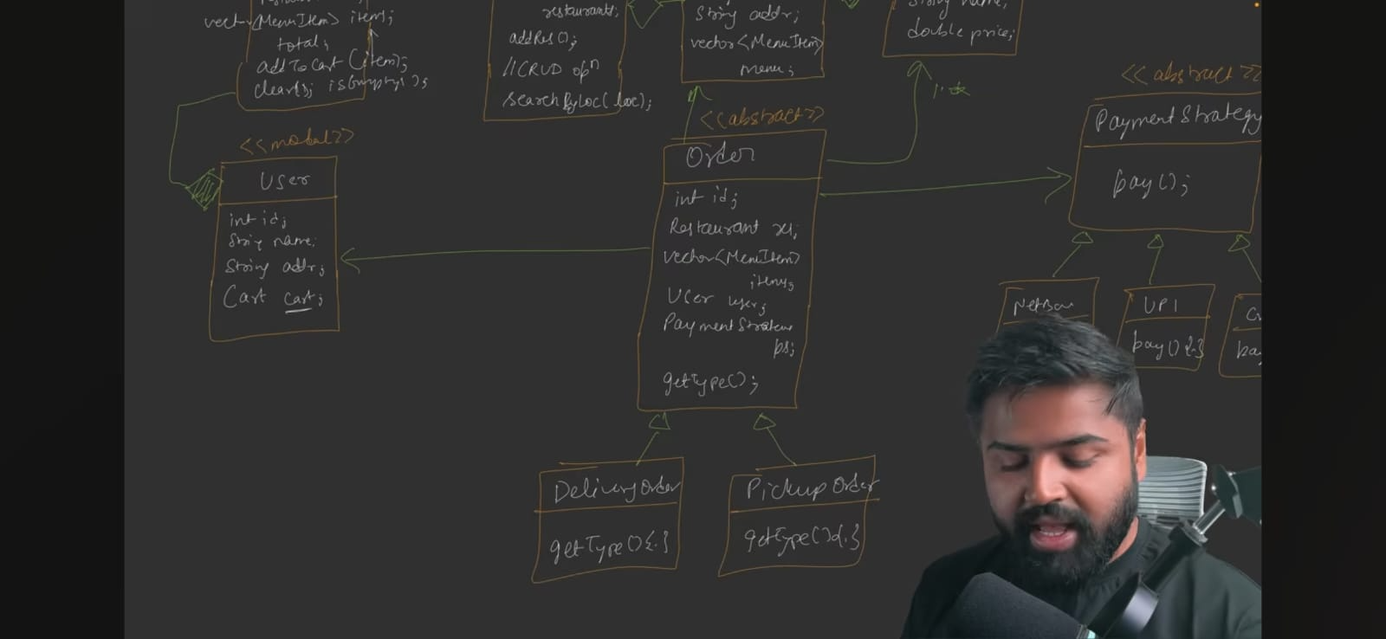
Let’s introduce the factory design pattern
There should be something to manage the order – to create, delete the order
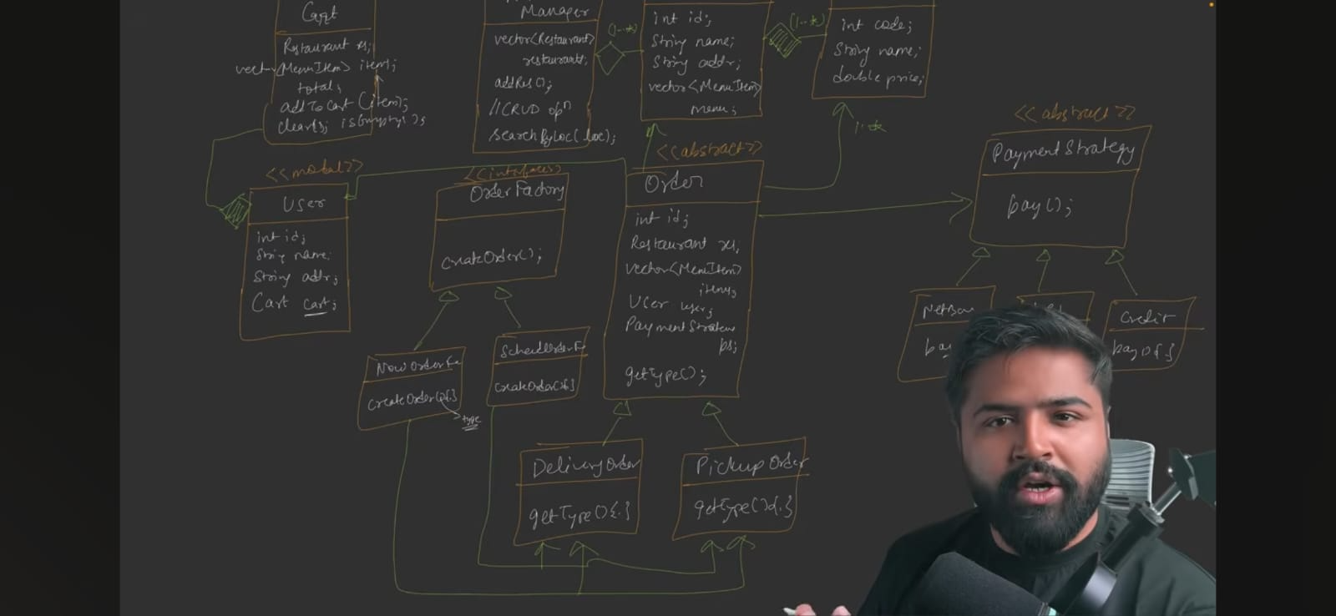

We could have make a factory design pattern in Restaurant also but theeis no need
Now we create a order manager which will manage the order or in future if we want to save it in DB also then order manager will do it
Manger is always Singleton
Now suppose we have a Notification service let’s integrate it in our design and it has-a relationship with order which takes the order, pick out the user details and send the notification
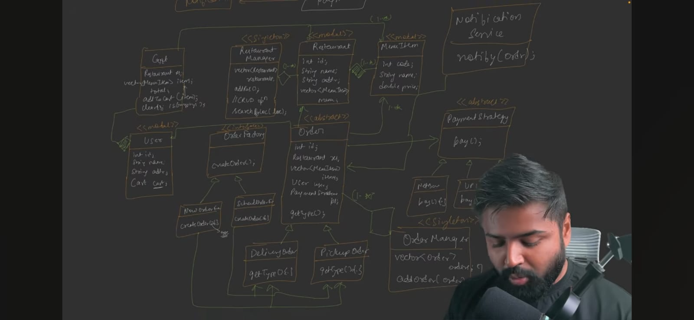
Now one class we are forgetting i.e Tomato class which will be in direct contact with client and it will interact with all the classes and it act as orchestrator.
it will just take a order from client and delegate the request to different classes
Now tomato class have all the knowledge of object and classes then only he van delegate the request to different classes so it is breaking the SRP and also the principal of least knowledge.
So it is not a perfect design there is always a trade-off
Clean UML Diagram:-
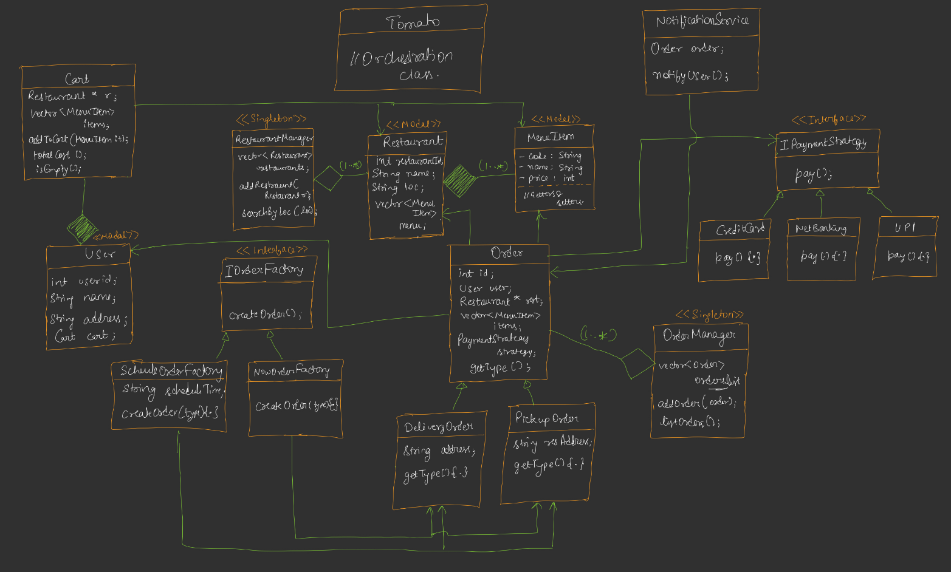

Code – See Notes..

Further Improvements:-
NotificationService – make it interface and implement different types of notification method.
We can improve Tomato class by adding controller, service, dao layer like in spring MVC

